**Assignment 6**

**Group: DWDM19G04**

**Roll Numbers: 2016BTECS00063, 2016BTECS00081, 2016BTECS00103**

**Batch: B7**

**Date: 21st October, 2019**

**Title: Association Rule Mining**

**Theory:**

Association Rule Mining, as the name suggests, association rules are simple If/Then statements that help discover relationships between seemingly independent relational databases or other data repositories.

Most machine learning algorithms work with numeric datasets and hence tend to be mathematical. However, association rule mining is suitable for non-numeric, categorical data and requires just a little bit more than simple counting.

Association rule mining is a procedure which aims to observe frequently occurring patterns, correlations, or associations from datasets found in various kinds of databases such as relational databases, transactional databases, and other forms of repositories.

Applications-

#### **Market Basket Analysis:**

This is the most typical example of association mining. Data is collected using barcode scanners in most supermarkets. This database, known as the “market basket” database, consists of a large number of records on past transactions. A single record lists all the items bought by a customer in one sale. Knowing which groups are inclined towards which set of items gives these shops the freedom to adjust the store layout and the store catalog to place the optimally concerning one another.

#### **Medical Diagnosis:**

Association rules in medical diagnosis can be useful for assisting physicians for curing patients. Diagnosis is not an easy process and has a scope of errors which may result in unreliable end-results. Using relational association rule mining, we can identify the probability of the occurrence of illness concerning various factors and symptoms. Further, using learning techniques, this interface can be extended by adding new symptoms and defining relationships between the new signs and the corresponding diseases.

**Tabular Result:**

|  |  |  |
| --- | --- | --- |
| **Support** | **Confidence** | **Page No** |
| 2 | 30 | 6686 |
| 2 | 60 | 5020 |
| 10 | 50 | 143 |
| 5 | 80 | 4963 |
| 10 | 60 | 102 |
| 7 | 75 | 60 |

**Output:**

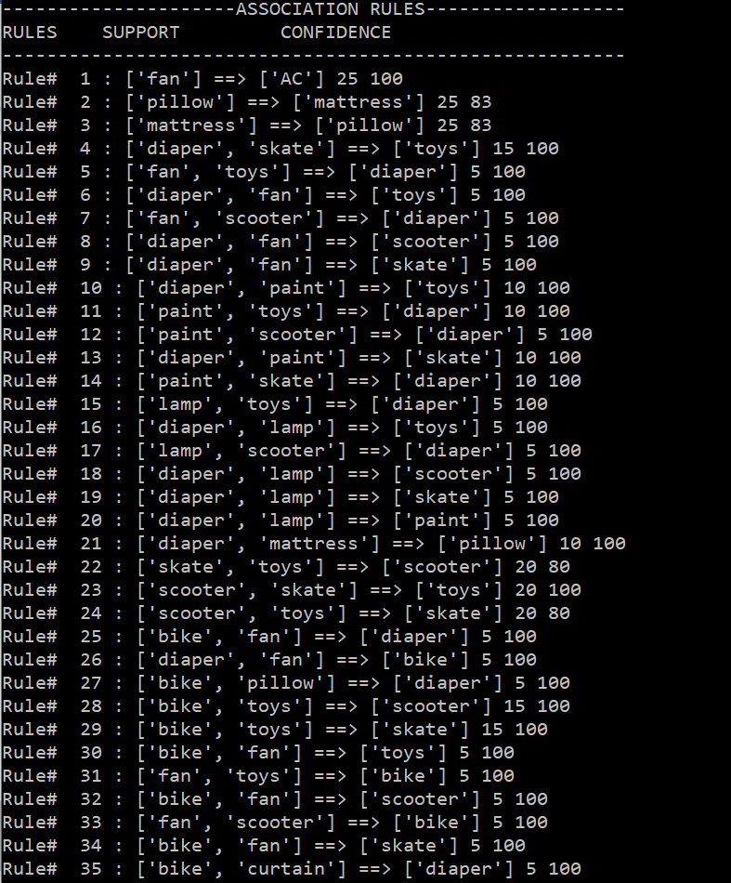

**Conclusion:**

This algorithm is used in finding frequent patterns, association, correlations or casual structures among sets of items or objects in transaction databases, relational databases and other information repositories. So, in a given transaction with multiple items, Association Rule Mining primarily tries to find the rules that govern how or why such products/items

are often bought together.